**Step one** – Go to D2L. Click on the tab that reads “0799-Fall 2024”.

Then, Click on the “2024-2025 Required Refresher Training” course tile.

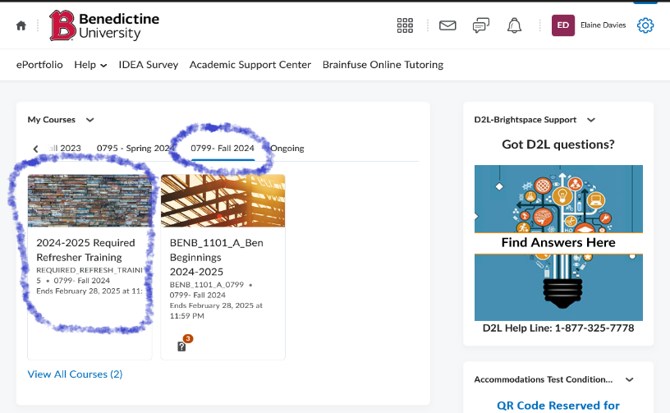

**Step 2:** Once in the course, on the left side of the screen, you will see the Content Browser. To begin the Trainings, click on Healthy Relationships Training

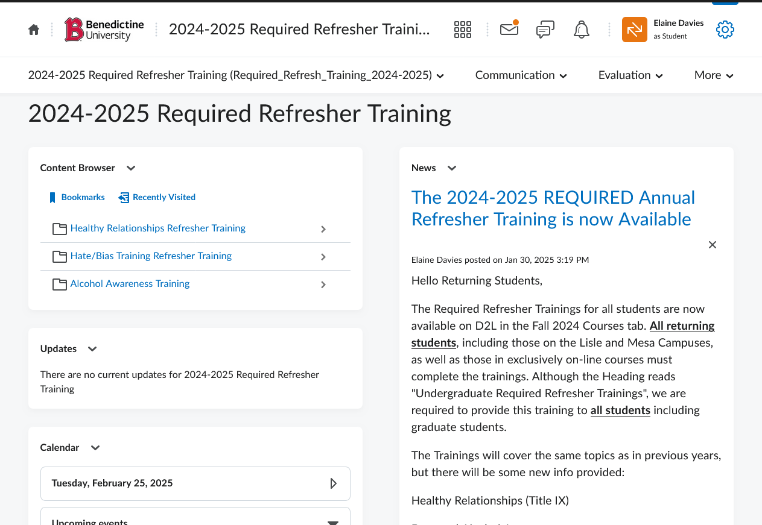

**Step 3: Click on the click on Re-introduction to Title IX.**

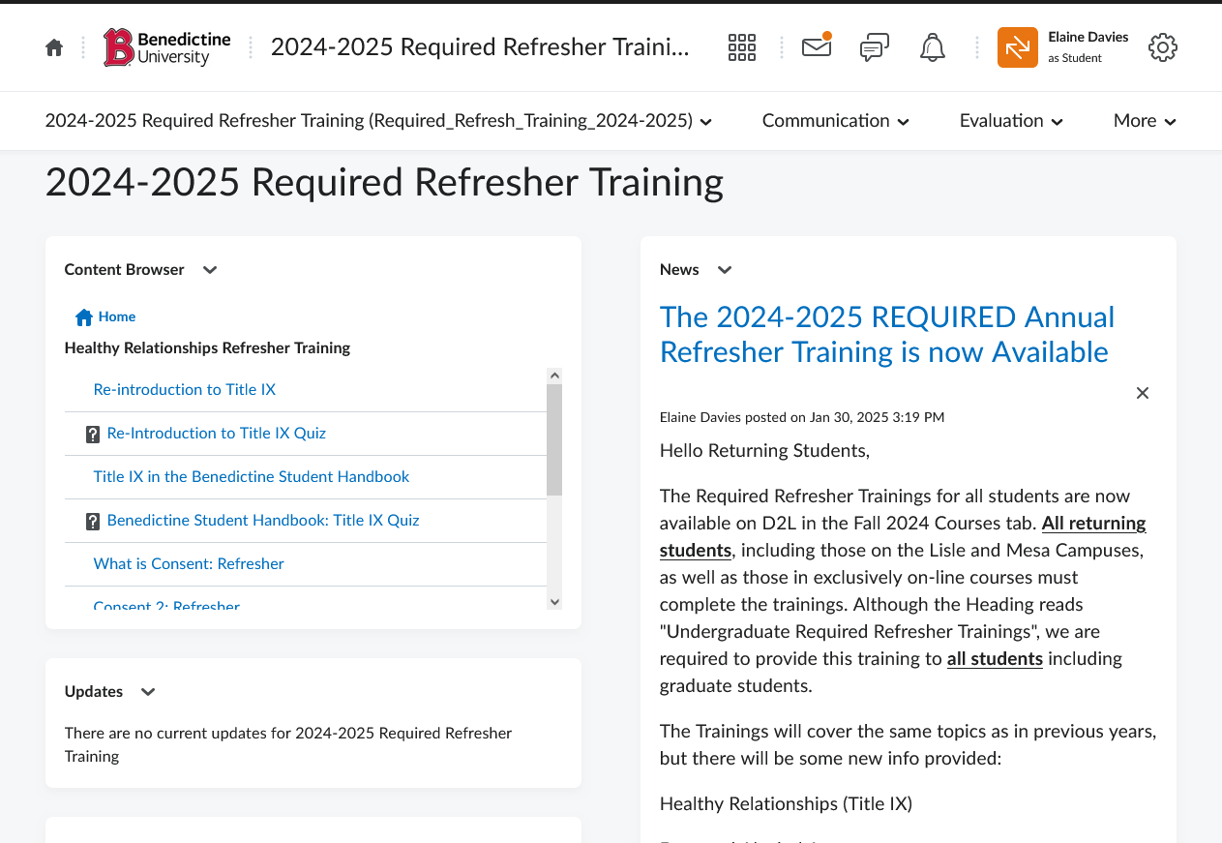

**Step 4: Watch the first video from start to finish. You will then be taken to the Re-introduction to Title IX Quiz.** For all quizzes, you must score 100% correct to move on to the next lesson within the Training. You have unlimited attempts at each quiz to achieve 100%

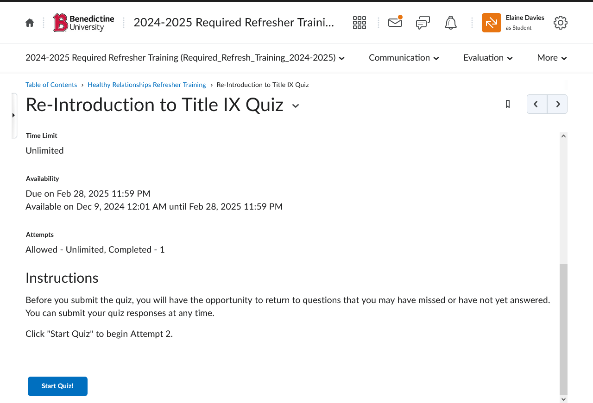

**Step 5:** After you have completed all materials in the Healthy Relationship Trainings module, you can move on to the Welcome to the Hate/Bias Training.

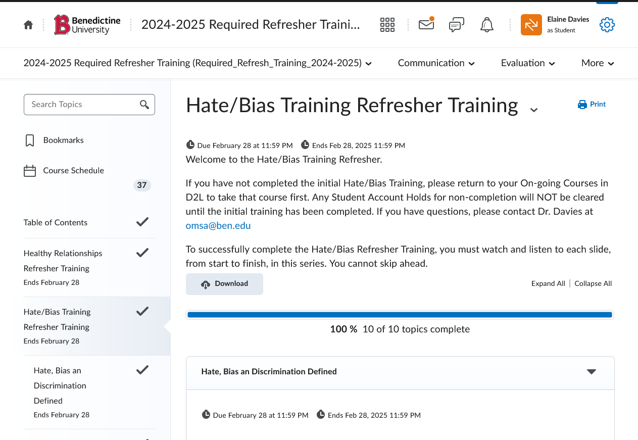

**Step 6:** Please remember, you must watch and listen to all slides in order to move on in the Training.

**Step 7**: After you have completed all materials in the Hate/Bias Trainings module and received the REQUIRED passing scores on each quiz, you can move on to the Alcohol Awareness Training.

**Step 8**: Complete the Alcohol Awareness training.

**Helpful Tips:**

1. Please remember, for each of the three trainings, you must always complete the training in the order it is presented. You MUST watch read/watched all materials from start to finish to progress.

2. Keep the sound on. All trainings have sound, except the Alcohol Awareness Training.

3. Keep track of your quiz scores. If you do not pass a quiz with the required score, you have unlimited times to re-take the quiz until you do earn the passing grade.

4. You will NOT be able to move forward through the trainings until you pass each quiz.

**Scores needed to pass each quiz**

**BenU Healthy Relationships Training (Title IX)**  
1. Re-Introduction to Title IX Quiz – 5/5

2. Benedictine Student Handbook Quiz – 2/2

3. Consent Quiz - 3/3

**Hate/Bias Training:**  
1. Discrimination and Protected Classes Quiz – 2/2  
2. Reporting Instances Quiz – 2/2

3. Free Speech Quiz – 3/3

**Drug and Alcohol Awareness Training:**  
1. Drug and Alcohol Impacts: Quiz 1 - 100%  
2. Alcohol: Quiz 2 - 100%  
3. Marijuana: Quiz 3 - 100%  
4. Resources: Quiz 4 - 100%

**Checking Your Quiz Scores in the Gradebook**

To check your quiz scores, click on the "evaluation tab."

If you do not see a specific quiz listed in your gradebook, it means you have not completed the material in the module that precedes the quiz.

Remember, you MUST watch/read/listen to each item within a module from start to finish. Only after the materials are completed, will the quiz be available to you.

**If you have any difficulty, please email Dr. Davies at omsa@ben.edu. Include your name, ID number, as well as a screenshot and complete description of the issue.**